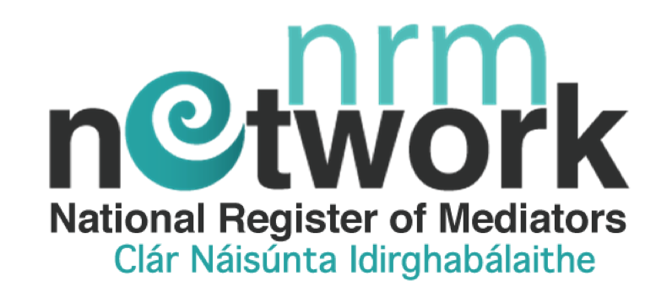

NRM TRAINEE MEDIATOR
WEBSITE LISTING APPLICATION FORM

Your General Details
Email Address
Title
First Name
Last Name
Address (Non-Public Profile)
Line 1
Line 2
Town
County
Country
Address (Public Profile Version)
County
Website
Mobile
Office Landline

Name of Certified Mediation Training Programme (CMTP):

___________________________________________________________________
Please note
Your course provider must be an approved CMTP to qualify for trainee membership

.
BANK DETAILS

Payment of Membership Contribution made payable to
NRM Network CO. LTD t/a National Register of Mediators

via bank transfer or online banking
(NB: Please ensure to use your name as a reference and please wait until your membership is approved)

IBAN: IE85 BOFI 9040 3480 0632 03 BIC: BOFI IE 2D

Fee Contribution Structure
Trainee Mediator Listing & Membership | 25.00 euro
Membership / listing for a 12 month period from date of issue
This student listing fee may be off-set against your first listing fee when qualified

Code of Conduct & Complaint Process & Privacy Declaration

- I have read and agree to be governed by the NRM Network code of professional conduct
- I have read and agree to be governed by the NRM Network's complaint and appeals process
- I have read and agree to the NRM’s privacy policy
- I understand and I give permission for the NRM Network to request to see my final assessment video role-play from my CMTP Provider when applying for Qualified or Certified Membership in the future.
- I agree that the NRM Network may contact me though the contact information provided.

Signed: ________________________________ Date: ____________

(We also accept an electronic signature)

NRM Network CLG is a non-profit registered charity in Ireland. Registered in Dublin, Ireland.
Charity Registration No. 20205432. Company Registration No. 565601

